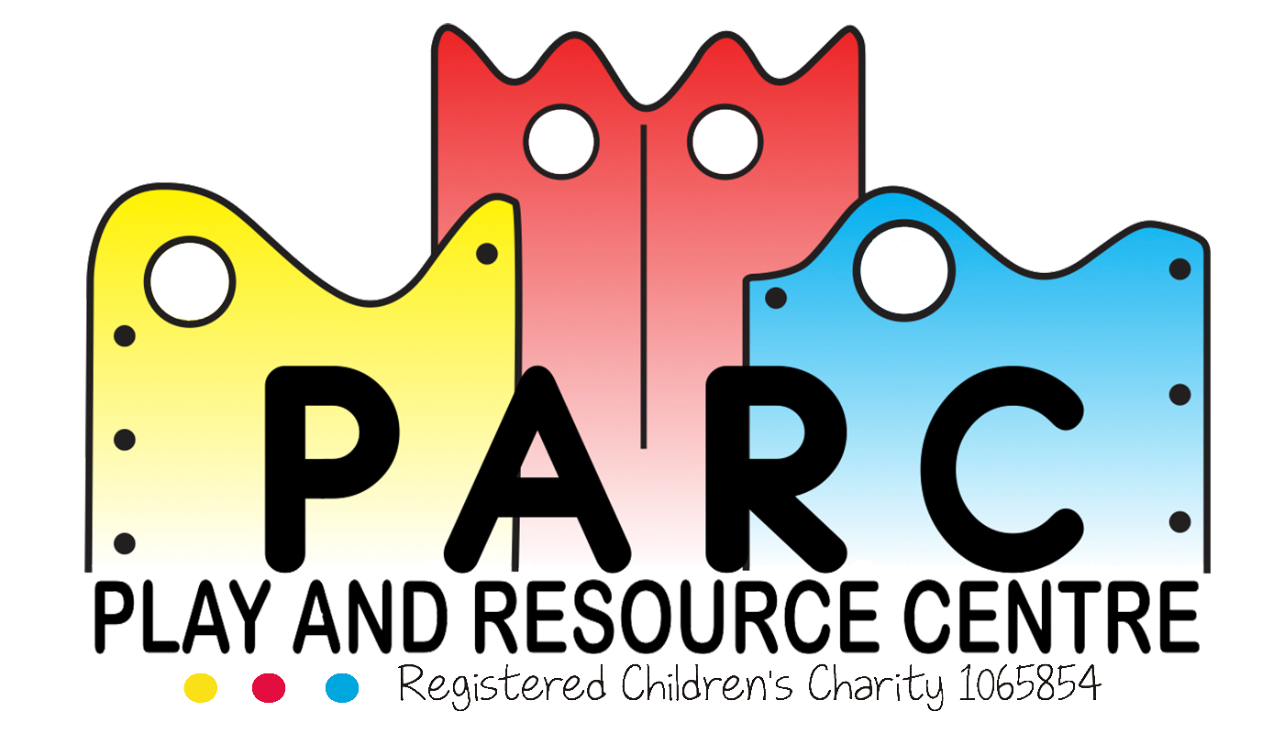

Behaviour & Anti Bullying

PARC (Essex)

|  |
| --- |
|  |
| February 2019 LT (V6) |
| Review 2 yearly |

It is the intention of the PARC Committee to ensure that everyone who enters the PARC premises are treated with courtesy and respect.

As we are an organisation which offers services to such a wide range of children in both age and capability we need to have certain basic rules.

Harmful behaviour and bullying cannot be accepted.

PARC will support and work with the child’s parents to help them overcome any difficulty.

When a child starts coming to the centre it is essential that we be informed of any behaviour which may cause a problem.

Redirection, removal of potential problems and positive reinforcement are used. Children are never left alone having behaved incorrectly. The whole episode is dealt with and concluded by a trusted member of staff.

We hope to build up caring, supportive relationships with both parents and children through which we can support the whole family. Occasionally it is necessary to work with parents to introduce a consistent approach.

Any harmful behaviour or bullying, which continues, will be brought to the attention of the team leader who will endeavour to support the child on a one to one basis with the support of carers.

Similarly we would appreciate the co-operation of the child’s family to keep us informed of anything in the child’s life, which may disrupt his or her behaviour. We would much rather put in extra support for your child in a positive, preventative way.

The Team Leaders and Managers will oversee any problems, liaise with parents, professionals and staff and keep up to date with training.

Staff receive ongoing training on behaviour management.

Incidents must be recorded in the incident file but will be shown to the parents concerned. Very serious incidents must be reported to Ofsted and the Charity Commission.

Records to be kept for two years for Ofsted and twenty-one years for legal reasons.

**Revised February 2019 LT (V6)**