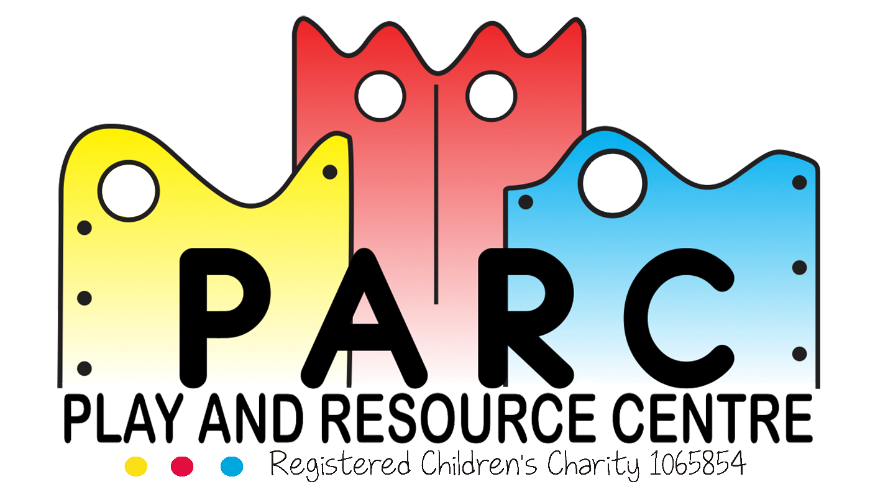

Social Media

PARC (Essex)

|  |
| --- |
|  |
| March 2019 LT (V4) |
| Review annually |

PARC recognises that Trustees, Staff and Volunteers might wish to use social media in a personal capacity in their own time.

The Trustees and Senior Management of PARC aim to safeguard staff, volunteers, service users, plus their families and all parties connected with PARC from the affects of Social Media.

The purpose of this policy is to outline the responsibilities of all connected parties when using social media given the potential for PARC affiliation and association, either explicitly or implicitly, and the risk of disclosing private or confidential information about the children who use the centre or their families, or voicing opinions which can be perceived to have a negative effect on PARC’s reputation. This policy does not relate to the PARC’s corporate use of social media for business purposes.

Examples of social media include: blogs, wikis, social networking sites such as Facebook, Twitter, Instagram, podcasts and message boards. In particular staff are reminded that they must not engage in public debate on any issue that relates to PARC, or PARC staff, without prior authority from one of the Senior Managers.

**Your responsibilities to PARC when using social media**

You should be aware that social media websites are a public forum, particularly if you are part of a ‘network’. You should not assume that your entries on any website will remain private. You are personally responsible for the content you publish on blogs, wikis or any form of social media. You should be mindful that what you publish will be public for a long time.

You must comply with the following when contributing to such sites even when it is in your own time and using your own IT equipment:

* You must not enter into any public debate on any issues that relate to PARC.
* You must not allow your interaction on these websites to damage working relationships between members of staff, service users or their families, or business contacts of PARC.
* You should not make any comments / statements or use language that could potentially undermine or damage the reputation of PARC even if there is no direct mention of PARC.
* You must ensure that no information is made available that could provide a person with unauthorised access to confidential PARC information.
* You must not record or disclose any confidential information regarding PARC, the children who use the centre or their families on any social media website.
* You must not use your PARC email address to register on such sites.
* If you tell others that you work for PARC as might be required or appropriate, you must ensure that by doing you do not breach any of the above. If you are unsure, seek guidance from your manager in the first instance.

Contravention of this policy could lead to disciplinary procedures or legal sanctions for all parties whether staff, volunteer or trustee.

**Families and Visitors**

**Tapestry:** Photographs of your child with one or more of their peers that appear within the Tapestry Learning Journeys must not be shared on any social media websites under any circumstances.

**Derogatory Posts and Comments:** It is requested that Social Media is not used as the platform to raise complaints or concerns on any PARC related matters whether explicitly or implicitly.

It is requested that you follow the correct channels by speaking to a senior staff member, or if that is not appropriate, the CEO or the Chair of Trustees to resolve any issues.

If unacceptable posts or comments are published, a PARC representative will, in the first instance, speak directly with you and ask that you refrain from such actions.

If it is repeated a legal letter detailing PARC’s concerns will be activated.

Continued actions of this nature will result in your attendance at PARC being denied.

**Revised March 2019 LT (V4)**