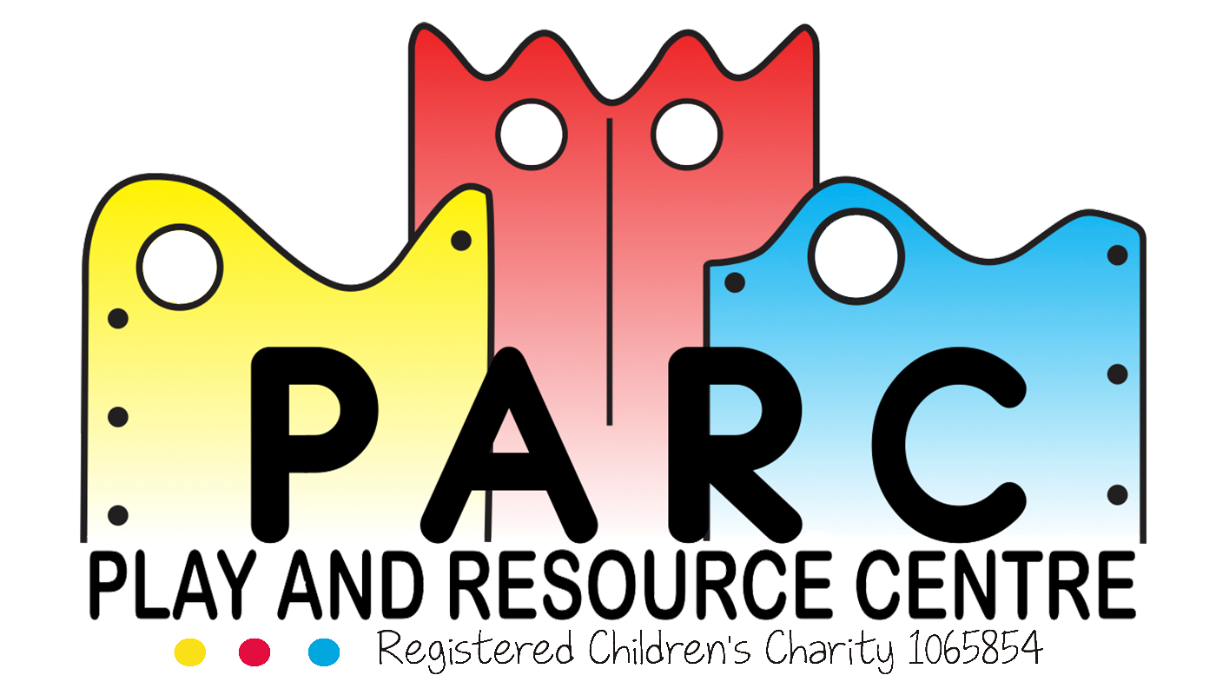

Safer Staff Recruitment

PARC (Essex)

|  |
| --- |
|  |
| March 2019 LT (V4) |
| Review 2 yearly |

It is the intention of the PARC Committee to ensure equality for everyone in their staff recruitment process and to ensure that safer recruitment is adhered to.

When a position at the centre becomes available it will be advertised in a number of ways:

* An advertisement will be placed on the staff notice board detailing the vacancy.
* An advertisement will be placed on the PARC website.
* We may advertise on job vacancy websites and centres.
* We may advise the position in local schools and colleges.
* We may follow up recent letters of enquires.
* Existing staff will be able to apply to increase their hours or change their job.
* Volunteer helpers will be given the details if requested.
* The Team Leaders where possible will attend the local college’s staff recruitment days.

Once a candidate enquires they will be selected through the following process:

* + An application pack and job details will be sent to the prospective candidate along with a link to the PARC website where they will find information on all our policies (including our equal opportunities policy).
  + They are then required to read through all information and complete any forms including two reference requests and send the information back to the office.
  + Their references will be sent off.

* + They will then be asked to arrange a visit to the centre and bring two forms of identity and their national insurance number in order to complete a DBS Check.
  + They will then be asked to fill in the DBS check form.
  + Their DBS check form will be sent off.
  + Once the DBS check and the references have been returned, depending on the outcome, it will be decided if this person is suitable.
  + If they are successful they will then be invited to have an interview.
  + They will be shown around the centre.
  + If they are successful in the interview, they will be contacted and trial days will then be organised.
* If the applicant’s trial days were a success and PARC would like them to be employed as a member of staff, they will be contacted and hours can be discussed.
  + PARC policies must be read, understood and signed as read prior to a staff member starting their first session.

All those responsible for appointing staff will be reminded of the PARC Equal Opportunities Policy and will also have completed Safe recruitment training to ensure the safety and wellbeing of all PARC members.

Before official hours start the applicant will have to complete an induction/training day.

Each successful candidate will be introduced to their supervisor, given regular supervision and support, positive feedback and adequate training, equipment and services to perform their tasks efficiently.

This process will be followed for all Service roles. It will differ slightly for Office roles as trial days are not necessary.

**Revised March 2019 LT (V4)**