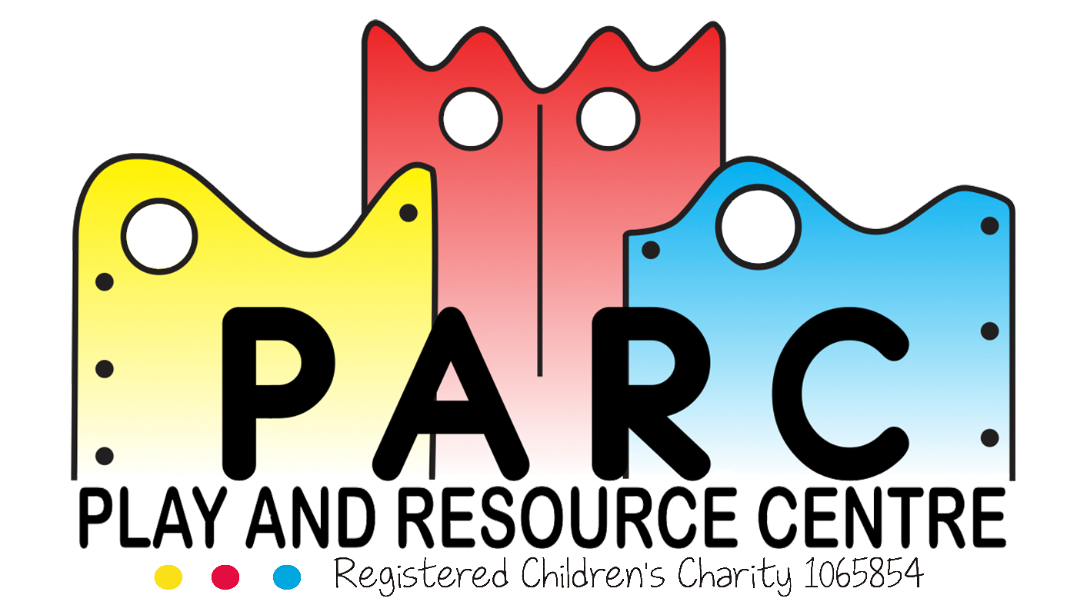

Fire and Evacuation Policy & Record Keeping

PARC (Essex)

|  |
| --- |
| Statutory |
| February 2019 LT (V5) |
| Review annually |

Regular evacuation and fire drill procedures will take place at least once every four months with a rotation of sessions. All staff and children/young adults will be informed when they will happen.

In the event of an emergency; the alarms either situated in the main lobby, main play area or kitchen area should be activated **immediately.**

On hearing the alarm, staff will gather the children and evacuate the building either through the main play area fire doors, the main lobby area, or the kitchen doors following the emergency exit signs. The children/young adults will then be led outside and following the pathway leading to the underpass (under the bridge). This needs to be a distance of at least 18 metres away from the building, but no more than 50 metres.

If the main gates are not accessible (I.E. the area is blocked by gas cylinder catching fire) then the playground can be used for evacuation purposes.

The Team leader or Fire Marshall for the evacuation will collect the signing in sheets, visitors book, mobile phone, children’s and adult’s emergency details, emergency jackets, water, blankets and first aid box and will lead the children and staff/volunteers/parents to the emergency assembly point (The forms, phone, emergency details, blankets, water to drink, biscuits etc. Are kept together in a box in the main lobby.) The deputy team leader will assist in getting everyone to the assembly point and will call the emergency services.

The Manager on site will conduct a sweep of the building ensuring everyone is out safely and closing all doors before safely leaving the building. The playground should also be checked.

**Parents who attend sessions are responsible for their child/children in evacuation circumstances and are to leave the building immediately through the nearest fire exit and follow the pathway to the underpass along with the staff.**

A roll call of all the children, staff, parents and visitors will be made to ensure that no one has been left behind. No one is to enter the building until the emergency services have declared it is safe.

Staff will endeavour to contact parents if they are not present.

**PARC policy is to evacuate the building not to tackle the fire.**

**Fire Drills are Recorded in the Fire Log Book. Chris Frisbee is the Named Fire Safety Officer.**

**Drills are scheduled to be conducted in rotation so all session staff are involved in the evacuation and drill procedures for a variety of the sessions that PARC host.**

**Revised February 2019 LT (V5)**