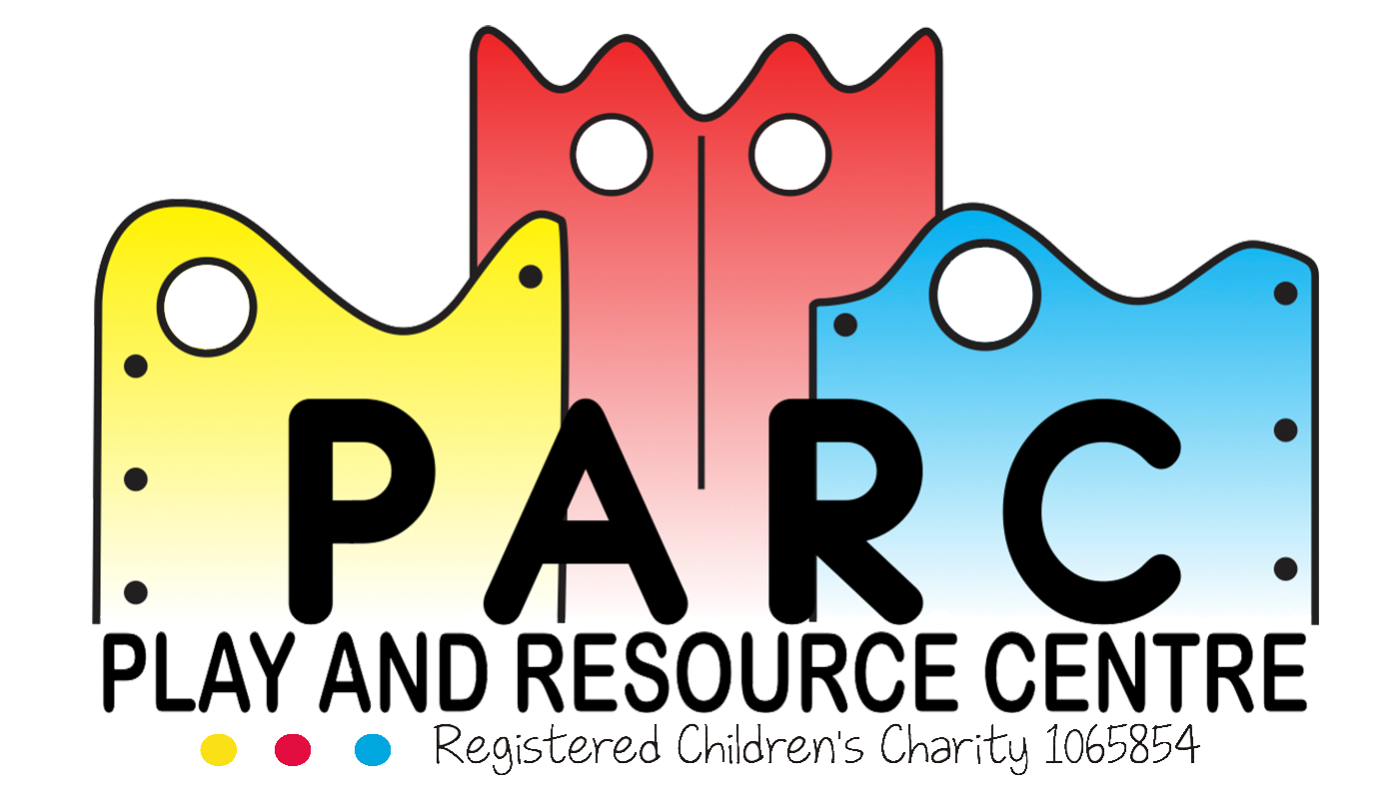

Food and Drink Policy

PARC (Essex)

|  |
| --- |
|  |
| April 2019 LT (V4) |
| Review 2 yearly |

It is the intention of the PARC Committee to provide an adequate and high standard of refreshment for the service users, staff and volunteers.

Staff should be aware that drinking water should be available and offered to children frequently. They must also be aware that the children will need more refreshments in hot weather.

Staff should be aware of children’s allergies, their dietary requirements, likes and dislikes.

When lunch boxes are brought on site they must be checked and stored in the children’s fridge in the kitchen.

Children must not be allowed to swap food and must be supervised at all times when eating.

Staff planning any snack to be offered, will take note of any Government guidelines.

Parents/carers are asked not to bring in any foods containing nuts due to serious allergies. Nut containing products will not be consumed during the child’s time at the centre.

If a snack is to be offered, parents/carers and staff are asked to cut certain foods into quarters to prevent chocking e.g. grapes

No food or drink is permitted in the soft play area or the sensory rooms.

**Staff**

Staff are permitted to help themselves to water; squash is also available. We ask that staff do not consume food from the kitchen without checking with a Team Leader. If a member of staff consumes something which was needed they will be asked to replace it.

Staff MUST consume their lunch away from the children, in the kitchen or designated area if the kitchen is unavailable.

Staff are permitted to have a drink whenever needed, but we do ask that they do so with the children at snack time and during their water breaks, as to not disrupt the session too much. If a drinks break is needed outside of these times, please ensure your one to one or area is covered during this time. Hot drinks are not permitted in the sessions.

Emergency details must be kept up to date, so we are aware of any allergies.

Staff and Volunteers are asked not to bring in any foods containing nuts due to serious allergies.

**Revised April 2019 (V4)**