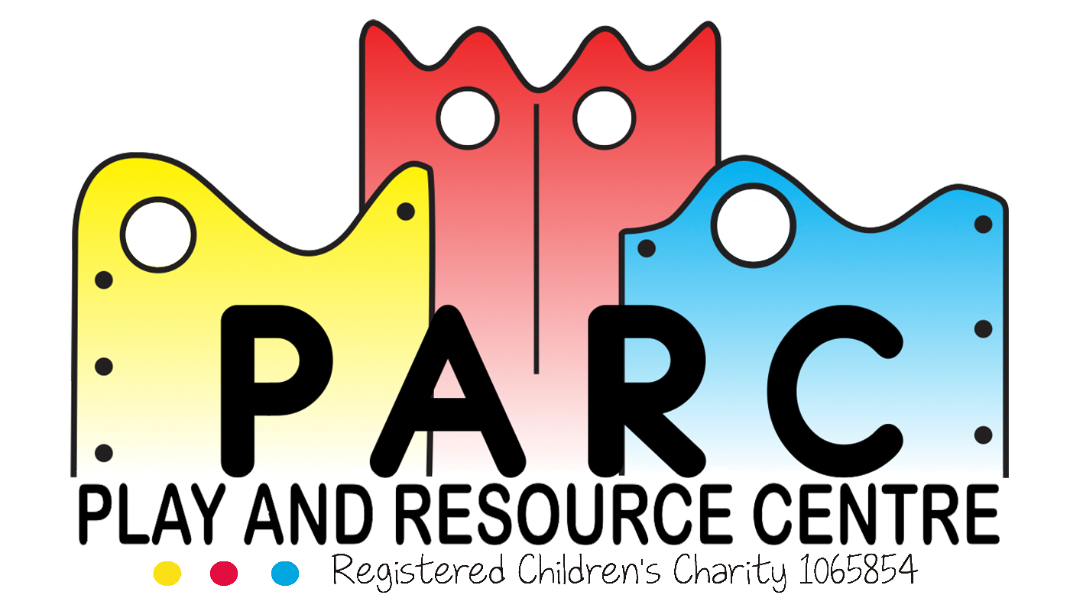

Whistle Blowing for Staff, Volunteers and Students

PARC (Essex)

It is the intention of the PARC Committee to enable everyone who is involved at PARC to feel able to report any activity which is detrimental to the reputation and future of PARC.

PARC expect ALL staff, volunteers and students to speak to their Line Manager and provide any information if suspecting fraud or corruption.

If a staff member, volunteer or student feels they cannot speak with their Line Manager they should alert a Senior Manager or the CEO.

Staff, volunteers and students are permitted to contact any member of the Committee if they feel that they cannot speak with someone at PARC.

Staff, volunteers and students MUST report any problems that they are within PARC.

All information and concerns will be treated seriously and in strict confidence.

If staff, volunteers or students feel that they need to report anything, please follow the grievance procedure.

**Revised December 2017 (V5)**